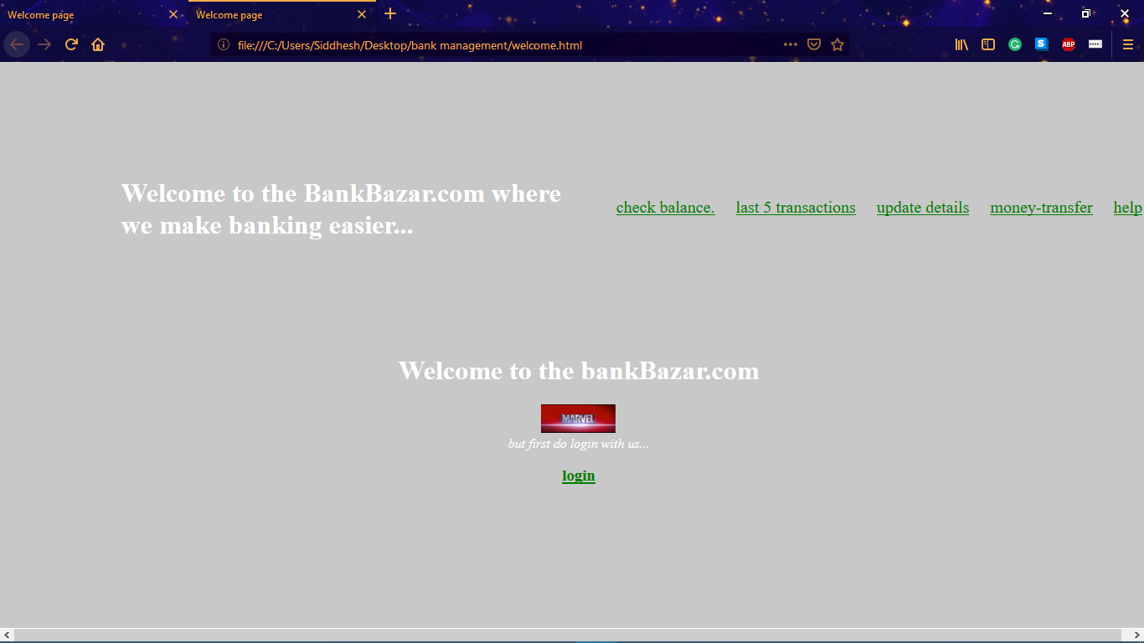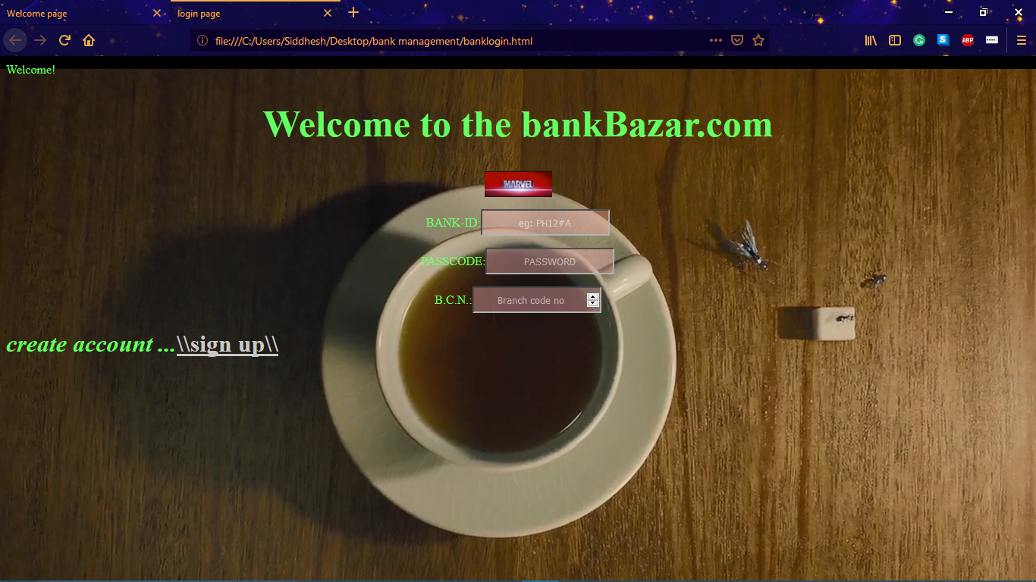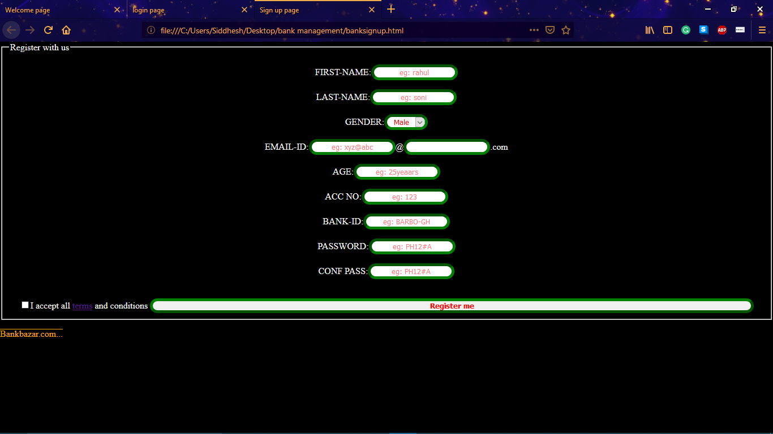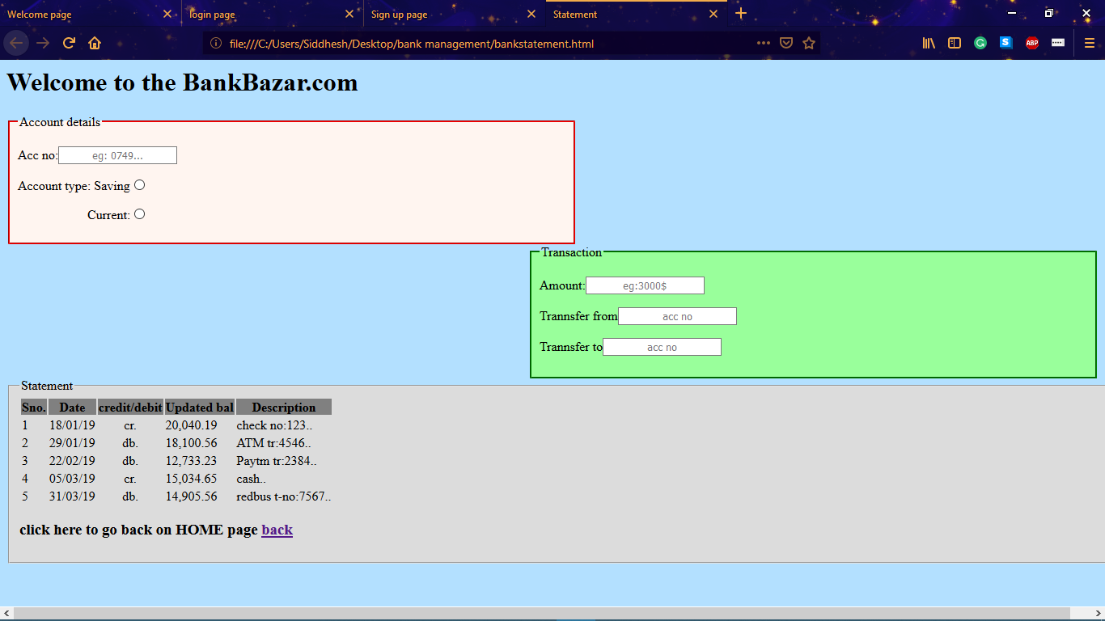

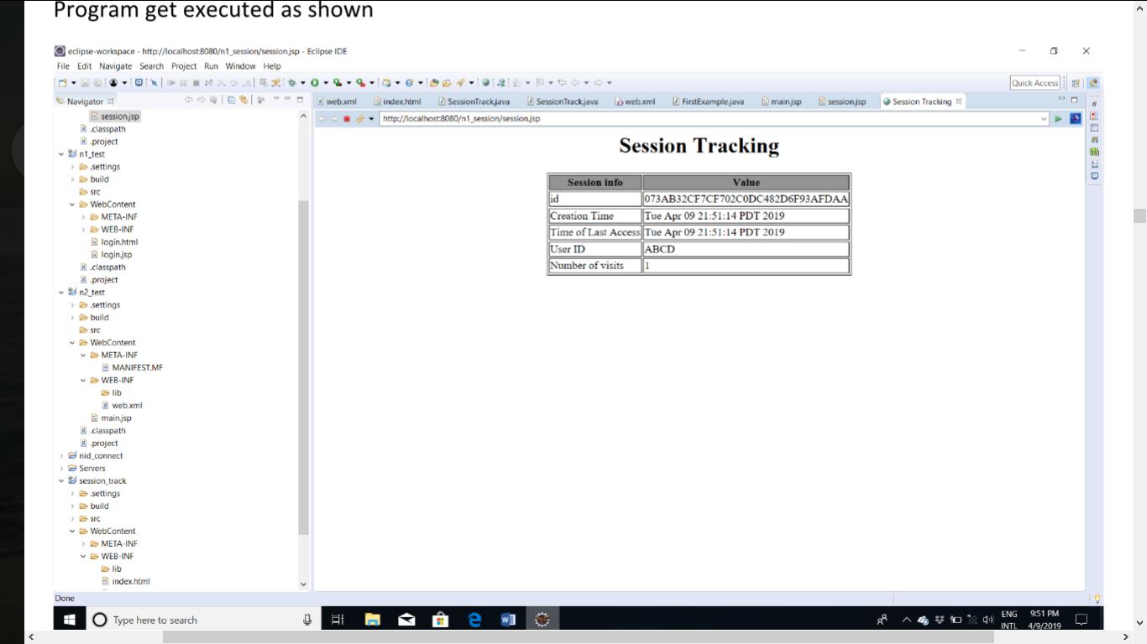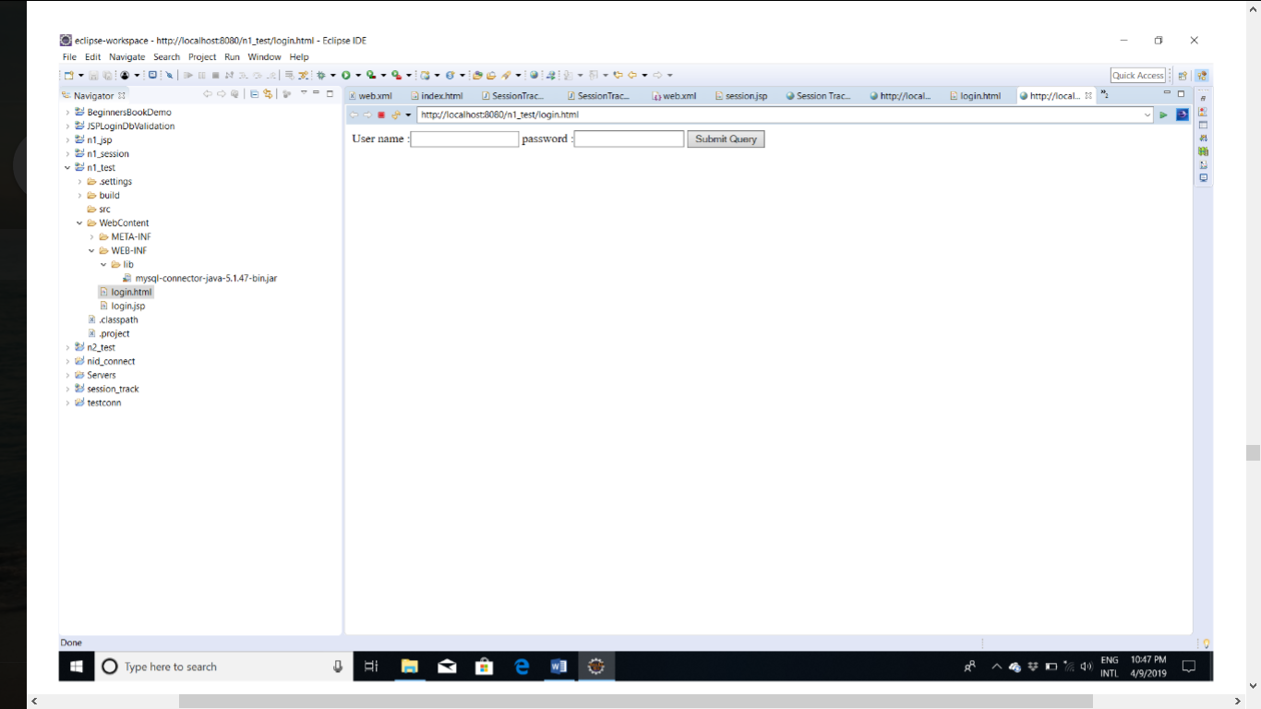

1.Welcome.html

<html><head>

<title>Welcome page</title>

<style type="text/css">

body{ background-color: rgba(200,200,200,1);

width: 100%;

height: 100%; }

ul{ float: right; }

h1:hover,i:hover{ transition-duration:0.6s;

color: rgba(250,250,250,0.5);}

a{ color: green;

height: 40px;

border-color: white; }

aside{ transition-property:background;

transition-duration:0.5s;

transition-timing-function:linear; }

.menu li{ display: inline-block;

padding: 5px 10px; }

div{ margin-top: 10%; }

li{ background: rgba(0,0,0,0,0);

width: auto;

height: 30px;

text-decoration: none; }

</style></head>

<body style="color:white">

<aside>

<ul class="menu" style="list-style-type:disc; text-decoration:none; font-size:20px;">

<li><a href="#">check balance.</a></li>

<li><a href="bankstatement.html">last 5 transactions</a></li>

<li><a href="#">update details</a></li>

<li><a href="#">money-transfer</a></li>

<li><a href="#">help</a></li> </ul> </aside>

<h1 class="theam">Welcome to the BankBazar.com where we make banking easier...</h1>

<center><div>

<h1>Welcome to the bankBazar.com</h1>

<img alt="company logo" src="ss3.png" width="89px;" height="34px;"><br/>

<i>but first do login with us... </i>

<h3><a href="banklogin.html" >login</a></h3> </div>

</center>

</body> </html>

2.login.html

<html><head>

<title>login page</title>

<style type="text/css">

input{ background-color: rgba(250,180,180,0.4);

color: white;

text-align: center;

border-color: black;

width: 170px;

height: 35px;}

input:hover{ width: 150px;

height: 25px;}

input:focus{ background-color: #8842d5;

width: 300px;

height:45px;}

</style></head>

<body background="ss2.png" style="color:rgb(100,300,100)">

<center>

<h1 style="font-size:50px;">Welcome to the bankBazar.com</h1>

<img alt="company logo" src="ss3.png" width="89px;" height="34px;"><br/>

<div> <p>BANK-ID:<input type="text" placeholder="eg: PH12#A"/></p>

<p>PASSCODE:<input type="PASSWORD" placeholder="PASSWORD"/></p>

<p>B.C.N.:<input type="NUMBER" placeholder="Branch code no"/></p>

</div>

</center>

<H1><i>create account ...</i><a style="color:rgb(200,200,200); " href="banksignup.html">\\sign up\\</a></H1>

</body>

</html>

3. Signup.html

<html><head>

<title>Sign up page</title>

<script type="text/javascript">

function func() { var check="a";

var str1=document.reg.fnam.value;

var str2=document.reg.lnam.value;

var str4=document.reg.no.value;

var str5=document.reg.pass.value;

var str6=document.reg.conf.value;

var s4= new RegExp("^[0-9]+$","g");

var s5= new RegExp("^[0-9 @ # a-z A-Z]+$","g");

var s1= new RegExp("^[a-z A-Z]+$","g");

if(!(str1.match(s1)))

{ check="b";

document.getElementById('fname').innerText="*only alphabets"; }

if(!(str2.match(s1)))

{ check="b";

document.getElementById('lnam').innerText="*only alphabets"; }

if(!(str4.match(s4)))

{ check="b";

document.getElementById('no').innerText="*only and min 16digits"; }

if(!(str5.match(s5)))

{ check="b";

document.getElementById('pass').innerText="*special char:@,# min:6 digits"; }

if(!(str6.match(str5)))

{ check="b";

document.getElementById('conf').innerText="*password not same";}

if(check=="a")

{ alert("validating...");

window.open("welcome.html","_self"); }

else { alert("not valid details"); } </script>

<link rel="stylesheet" type="text/css" href="signupcss.css"></head>

<body><center>

<form name="reg"><fieldset>

<legend>Register with us</legend>

FIRST-NAME:<input type="text" name="fnam" placeholder="eg: rahul" required/>

<span id="fname"></span>

LAST-NAME:<input type="text" name="lnam" placeholder="eg: soni" required/>

<span id="lnam"></span>

GENDER:<select name="gender" value="Gender" >

<option>Male</option>

<option>Female</option></select>

EMAIL-ID:<input type="mail" name="mail" placeholder="eg: xyz@abc" required/>@<input type="text" name="mail2" required/>.com

AGE:<input type="tel" name="age" placeholder="eg: 25yeaars" required/>

ACC NO:<input type="text" name="no" placeholder="eg: 123" required/>

<span id="no"></span>

BANK-ID:<input type="text" name="id" placeholder="eg: BARBO-GH" required/>

PASSWORD:<input type="password" name="pass" placeholder="eg: PH12#A" required/>

<span id="pass"></span>

CONF PASS:<input type="password" name="conf" placeholder="eg: PH12#A" required/>

<span id="conf"></span><br/>

<input type="checkbox" required/>I accept all <a href="#">terms</a> and conditions

<input class="sub" type="button" style="width:80%; height:20px text-align:center" value="Register me" onclick="func()">

</fieldset></form>

</body> </html>

4. Statement.html

<html><head>

<title>Statement</title>

<style type="text/css">

#ad{ width: 50%;

padding-left: 10px;

float: left;

border-color: red;

background-color: hsl(21,100%,97%);

transition-property:background;

transition-duration:1s;

transition-timing-function:linear; }

#ad:hover{ background-color: hsl(19,100%,80%); }

body{ background-color: #b3e0ff; }

#tr{ width:50%;

padding-left: 10px;

float: right;

border-color: green;

background-color: hsl(121,100%,97%);

transition-property:background;

transition-duration:1s;

transition-timing-function:linear; }

input{ text-align: center;

padding: 2px; }

#tr:hover{ background-color: hsl(121,100%,80%); }

#tst{ float: left;

background-color:gainsboro; }

input:hover{ background-color:black;

color:white; }

h3:hover{ background-color: lightgreen; }

input:focus{ border-color: red;

border-width: 3px;

color:black;

background-color: rgb(240,240,241);}

#a{ background-color: gray; }

</style></head>

<body>

<form> <fieldset id="ad">

<legend>Account details</legend>

<p>Acc no:<input type="text" name="no" placeholder="eg: 0749..." ></p>

<p>Account type:

Saving<input type="radio" ></p>

<p style="margin-left:86px;">Current:<input type="radio" ></p> </fieldset>

<fieldset id="tr">

<legend>Transaction</legend>

<p>Amount:<input type="text" placeholder="eg:3000$" ></p>

<p>Trannsfer from<input type="text" placeholder="acc no" ></p>

<p>Trannsfer to<input type="text" placeholder="acc no" ></p> </fieldset>

<fieldset id="tst"> <legend>Statement</legend>

<table border="0">

<tr id="a"> <th>Sno.</th><th>Date</th><th>credit/debit</th>

<th>Updated bal</th><th>Description</th></tr>

<tr id="b"> <td>1</td><td>18/01/19</td><td style=" text-align:center;">cr.</td>

<td>20,040.19</td><td>check no:123..</td></tr>

<tr id="c"> <td>2</td><td>29/01/19</td><td style=" text-align:center;">db.</td>

<td>18,100.56</td><td>ATM tr:4546..</td></tr>

<tr id="d"> <td>3</td><td>22/02/19</td><td style=" text-align:center;">db.</td>

<td>12,733.23</td><td>Paytm tr:2384..</td></tr>

<tr id="e"> <td>4</td><td>05/03/19</td><td style=" text-align:center;">cr.</td>

<td>15,034.65</td><td>cash..</td></tr>

<tr id="f"> <td>5</td><td>31/03/19</td><td style=" text-align:center;">db.</td>

<td>14,905.56</td><td>redbus t-no:7567..</td></tr></table>

<h3>click here to go back on HOME page <a href="welcome.html">back</a></h3>

</fieldset></form>

</body></html>